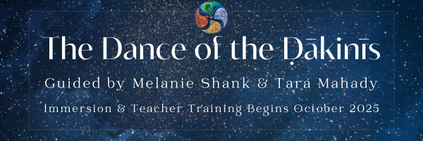

**Welcome,**

Thank You for taking the time to engage with this Application for the Dakini Mandala Immersion. Before you begin, we encourage you to go at your own pace and move through these questions in whatever way feels most easeful for you.

You’re welcome to share your responses in whichever format best suits your communication style, whether written, audio, or video. We honor the diverse ways people process and express themselves, and we warmly invite you to respond in the way that feels most natural to you.

* If you are writing your responses, feel free to type directly into this document or create a separate document with your responses. Then upload your response document to the Application page of the website.
* If you choose audio or video, please clearly indicate which question you’re answering and upload the audio or video recording to the Application page of the website.

**Application Prompts & Questions**

Name:

1. **Tell us about your path of self-discovery so far.**
   * We invite you to share any experiences, practices or insights that have shaped your spiritual, emotional, or embodied journey.
2. **Tell us about your interest in the Dakini Mandala Immersion.**

* What is drawing you to this work at this time in your life?
* What is it about the Dakini Mandala that speaks to you?
* Are there particular teachings, practices, or aspects of the immersion that feel especially alive or resonant for you right now?

1. **Practice Background**We’d love to learn more about your path. Please share your familiarity or experience with any of the following if it applies to you—there are no requirements or expectations. This helps us better understand where you’re coming from, the wisdom you carry, and what lights you up to explore more deeply.

* Meditation
* Mantra and Sanskrit
* Sādhana (personal spiritual practice commitments)
* Haṭha Yoga (any style or lineage) or Embodiment / Somatic Practices
* Tantra, Śrī Vidyā or any other lineage-based, Indigenous, or ancestral spiritual paths
* Ritual or devotional practice
* Shadow Work
* Nature-Based or Earth-Honoring Practices
* Subtle Body or Energy Work
* Other…

1. **Collective Engagement**
   * How do you imagine yourself contributing to the collective field of this immersion, not by offering formal training, but rather through the wisdom of your experience, presence, insight, care, curiosity, previous training or other ways that may not always be visible or conventional?
2. **Access and Support**
   * If there’s anything you’d like us to be aware of at this stage, any access needs, support requests, or ways we can better honor your experience, you’re welcome to share that here.
   * We’ll also invite a deeper check-in around this at a later stage in the application process.
3. **Commitment to Presence**

* This immersion is deeply rooted in relational practice and community transmission. Full participation in scheduled sessions including retreats, weekend immersions, and our twice-monthly gatherings is central to the integrity of this work and the collective experience we are co-creating.
* We recognize that life, health, and access needs may at times impact your ability to be physically present. With that in mind, we ask:
  + Are you able and willing to commit to attending the majority of sessions live online, as a gesture of your engagement with this shared journey and out of respect for your sangha mates and the collective nature of the work.
* If you are aware of any potential conflicts, access needs, or life circumstances that might affect your attendance, please share them below. We welcome this transparency and will hold your reflections with care as we shape the group container.

1. **Authorization Path**

* Is it your intention at this time to go through the authorization process? (It’s completely okay if you’re unsure. For now, we’re simply asking to get a sense of your current intentions.) *If no – you can skip the below questions.*
* If you feel called to share, what is drawing you toward the authorization path at this time?
  + You might reflect on your sense of readiness, your relationship to teaching or service, or how you imagine this path weaving into your life.
  + Whether your response is clear, emerging, or uncertain, we welcome whatever feels true for you right now.
* As part of your path to becoming an authorized guide of these teachings, there is a core responsibility to be present and engaged in the learning process.
  + We ask that you commit to attending at least 80% of the sessions live and online. Over time you will be given opportunities for space holding, leadership, and guiding, essential moments to practice and deepen your skills. So your live participation is important in terms of building trust and transparency in the group.
  + Are you able to commit to being present, live, and online for at least 80% of the sessions?